Appendix 2 - Tennis Court Investment Consultation Questionnaire Results
(Questions That Had Text Boxes Only To Complete Have Been Excluded. Percentages For Each Question Calculated from The Total Number of People Who Answered Each Question)

1. Where is your nearest park area with tennis courts?
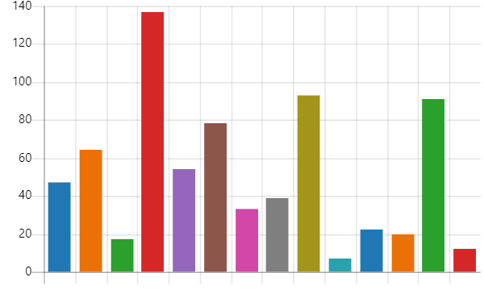
 | Byron Recreation Ground | 47 | 7%
 | Centenary Park | 64 | 9%
 | Chandos Recreation Ground | 17 | 2%
 | Harrow Recreation Ground | 137 | 19%
 | Harrow Weald Recreation Ground | 54 | 7%
 | Headstone Manor Recreation Ground | 78 | 11%
 | Kenton Recreation Ground | 33 | 5%
 | Montesole Playing Fields | 39 | 5%
 | Pinner Village Gardens | 93 | 13%
 | Queensbury Recreation Ground | 7 | 1%
 | Rayners Mead | 22 | 3%
 | Roxeth Recreation Ground | 20 | 3%
 | West Harrow Recreation Ground | 91 | 13%
 | Not sure | 12 | 2%

2. Do you currently use the tennis courts in Harrow’s parks?

 | Yes | 362 | 51%
 | No | 352 | 49%

3. Which park do you use most to play tennis?
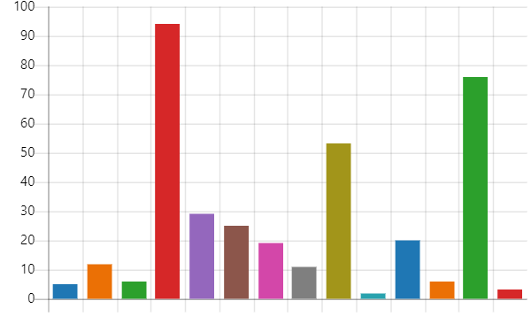
 | Byron Recreation Ground | 5 | 1%
 | Centenary Park | 12 | 3%
 | Chandos Recreation Ground | 6 | 2%
 | Harrow Recreation Ground | 94 | 26%
 | Harrow Weald Recreation Ground | 29 | 8%
 | Headstone Manor Recreation Ground | 25 | 7%
 | Kenton Recreation Ground | 19 | 5%
 | Montesole Playing Fields | 11 | 3%
 | Pinner Village Gardens | 53 | 15%
 | Queensbury Recreation Ground | 2 | 1%
 | Rayners Mead | 20 | 5%
 | Roxeth Recreation Ground | 6 | 2%
 | West Harrow Recreation Ground | 76 | 21%
 | Not sure | 3 | 1%

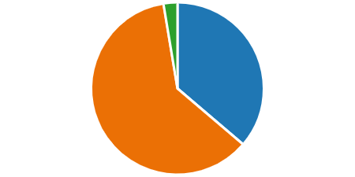
4. Who do you play tennis with?
 | Friends | 125 | 36%
 | Family | 211 | 61%
 | Other | 9 | 3%

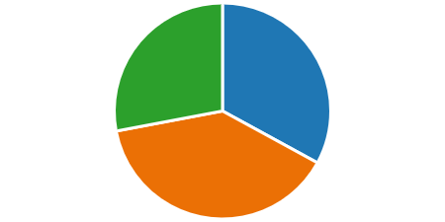
5. When did you last play at a Harrow Park?

 | Within the last week | 119 | 33%
 | Within the last month | 141 | 39%
 | Within the last year | 101 | 28%

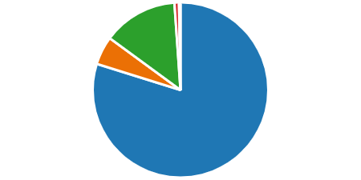
6. How do you get to the tennis courts?

 | Walk | 289 | 80%
 | Cycle | 19 | 5%
 | Drive | 50 | 14%
 | Public transport | 3 | 1%
 | Other | 1 | 0%

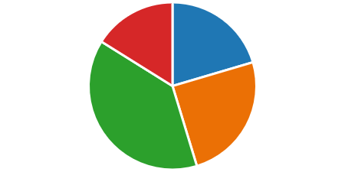
7. When do you play tennis?

 | Weekday daytime | 137 | 20%
 | Weekday evening | 167 | 25%
 | Weekend daytime | 259 | 39%
 | Weekend evening | 108 | 16%

10. Do other members of your household use the tennis courts in Harrow’s parks?
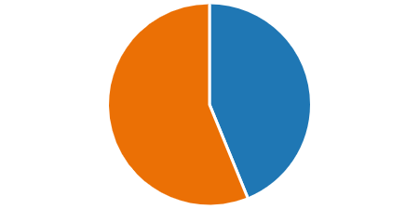
 | Yes | 312 | 44%
 | No | 400 | 56%

11. Which park do they use most to play tennis?
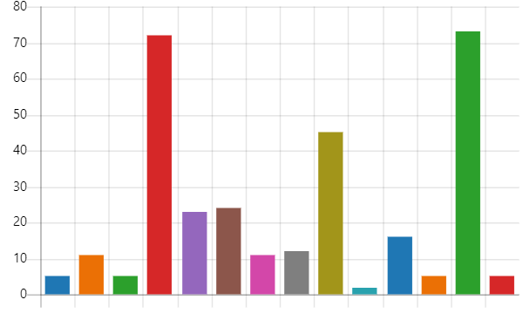
 | Byron Recreation Ground | 5 | 2%
 | Centenary Park | 11 | 3%
 | Chandos Recreation Ground | 5 | 2%
 | Harrow Recreation Ground | 72 | 23%
 | Harrow Weald Recreation Ground | 23 | 7%
 | Headstone Manor Recreation Ground | 24 | 8%
 | Kenton Recreation Ground | 11 | 3%
 | Montesole Playing Fields | 12 | 4%
 | Pinner Village Gardens | 45 | 14%
 | Queensbury Recreation Ground | 2 | 1%
 | Rayners Mead | 16 | 5%
 | Roxeth Recreation Ground | 5 | 2%
 | West Harrow Recreation Ground | 73 | 24%
 | Not sure | 5 | 2%

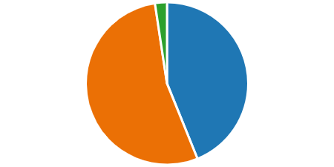
12. Who do they play tennis with?

 | Friends | 129 | 44%
 | Family | 158 | 54%
 | Other | 7 | 2%

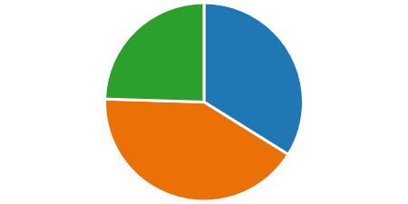
13. When did they last play at a Harrow park?

 | Within the last week | 105 | 34%
 | Within the last month | 129 | 42%
 | Within the last year | 76 | 24%

14. How do they get to the tennis courts?
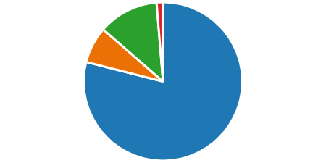
 | Walk | 244 | 79%
 | Cycle | 23 | 8%
 | Drive | 38 | 12%
 | Public transport | 4 | 1%
 | Other | 0 | 0%

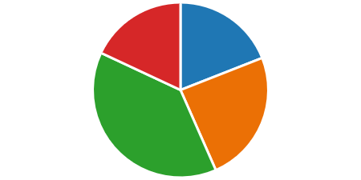
15. When do they play tennis?

 | Weekday daytime | 114 | 19%
 | Weekday evening | 146 | 24%
 | Weekend daytime | 231 | 39%
 | Weekend evening | 108 | 18%

18. Are you aware there are public tennis courts in 13 of Harrow’s parks?
 | Yes | 399 | 56%
 | No | 219 | 31%
 | Not Sure | 89 | 13%

19. If the condition of all the tennis courts in Harrow’s parks was improved, would your usage:
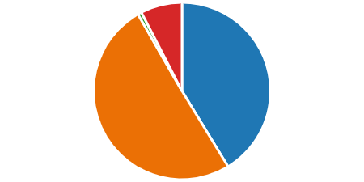
 | Remain the same | 294 | 41%
 | Increase | 359 | 50%
 | Decrease | 5 | 1%
 | Not sure | 54 | 8%

20. If you already play tennis in our parks, would you use a different court if it were in better condition e.g. nearer to your home?
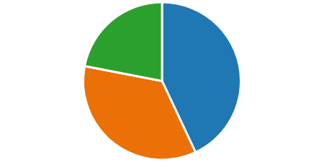
 | Yes | 286 | 43%
 | No | 233 | 35%
 | Not sure | 146 | 22%

21. If you do not play tennis on a regular basis, what would motivate you to play more?

 | Better court facilities | 317 |  | 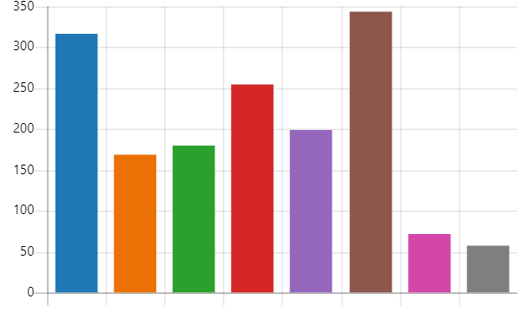  20%
 | Coaching | 168 |  | 11%
 | Someone to play with | 180 |  | 11%
 | Available when I want to play | 255 |  | 16%
 | Ability to book in advance | 199 |  | 12%
 | Free access to tennis | 343 |  | 22%
 | Access to equipment | 71 |  | 4%
 | Other | 58 |  | 4%

22. Which of these statements do you agree with?
 | Yes, I am in favour of the investment and for an external operator to run the courts on the council’s behalf. I understand this will mean charges for tennis court users. | 404 | 57%
 | No, I do not want the council to pursue the grant to renovate the tennis courts. I understand this will mean they will not be renovated as other funding sources have not been identified and some sites will remain closed/unplayable. | 310 | 43%

Those living near courts assessed as unplayable responses:
- Byron Recreation Ground – 47 responses
  - For – 35 (74%)
  - Against – 12 (26%)
- Centenary Park – 64 responses
  - For – 54 (84%)
  - Against – 10 (16%)
- Headstone Manor Recreation Ground – 78 responses
  - For – 56 (72%)
  - Against – 22 (28%)

Those living near courts assessed as very good or good courts responses:
- Rayners Mead – 22 responses
- For – 9 (41%)
- Against – 13 (59%)
- Pinner Village Gardens – 93 responses
- For – 55 (59%)
- Against – 38 (41%)
- West Harrow Rec – 91 responses
- For – 26 (29%)
- Against – 65 (71%)

23. If the council proceeds with the investment, what would you be prepared to pay for the hire of a tennis court in Harrow?
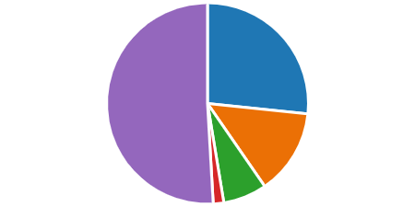
 | £3-5 per hour | 190 | 26.7%
 | £5-£7 per hour | 98 | 13.7%
 | £7-£10 per hour | 50 | 7.0%
 | £10- £12 per hour | 12 | 1.7%
 | I don’t think there should be any charge | 363 | 50.9%

24. If the council proceeds with the investment, which of the below groups do you think should be offered discounted court hire?
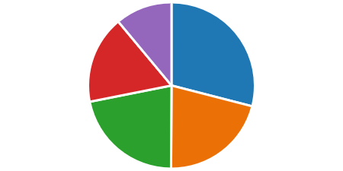
 | Children under 18 | 521 | 29%
 | Adults over 65 | 378 | 21%
 | Disabled people | 391 | 22%
 | Those claiming Universal Credit | 307 | 17%
 | Other | 198 | 11%

25.Do you think an online booking system would help you to play more/less tennis?
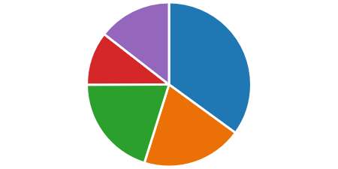
 | I would play more tennis | 249 | 35%
 | I would play about the same | 141 | 20%
 | I would play less tennis | 143 | 20%
 | I do not want to play tennis, so it does not affect me | 75 | 11%
 | Not sure | 103 | 14%

26. What are your thoughts about paying for the hire of tennis courts via the online booking system?
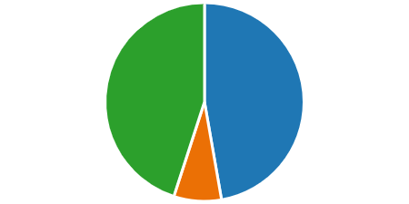
 | I would be in favour if the courts were improved, and I could book a court at a time that suits me | 336 | 47%
 | I do not currently play, or intend to play tennis, so it does not affect me | 55 | 8%
 | I would not be in favour | 320 | 45%

28. If the council proceeds with the investment, would you be in favour of some free coach led sessions targeted at specific groups?

 | Yes | 442 | 63%
 | No | 136 | 19%
 | Not sure | 124 | 18%

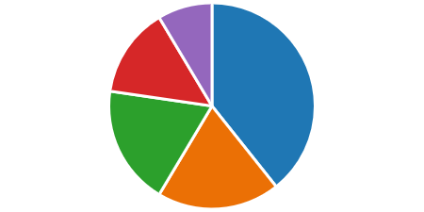
29. Which would be of interest?

 | Children under 18, | 367 | 39%
 | Adults over 65 | 180 | 19%
 | Disabled people | 175 | 19%
 | Those claiming Universal Credit | 132 | 14%
 | Other | 80 | 9%

30. What days of the week and time of the day do you think the free coach led sessions should be held?
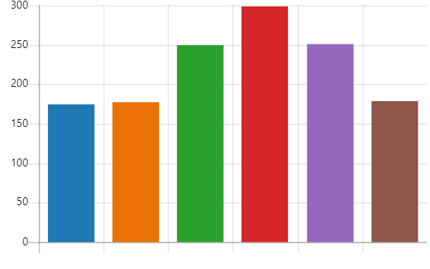
 | Weekdays - Morning | 175 | 13%
 | Weekdays - Afternoons | 177 | 13%
 | Weekdays -Evenings | 249 | 19%
 | Weekends - Mornings | 298 | 23%
 | Weekends - Afternoons | 251 | 19%
 | Weekends - Evenings | 178 | 13%

31. Are there any specific types of sessions you would like to see?
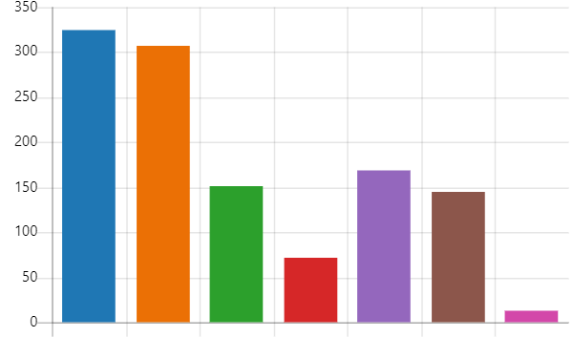
 | Youth | 324 | 28%
 | Adult beginner | 307 | 26%
 | Adult intermediate | 151 | 13%
 | Adult advanced | 71 | 6%
 | Cardio tennis | 169 | 14%
 | Walking tennis | 145 | 12%
 | Other | 12 | 1%

32. Would you be in favour of competitive tennis opportunities with people of a similar ability?
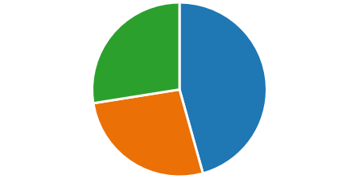
 |  | Yes | 317 | 46%
 |  | No | 186 | 27%
 |  | Unsure | 191 | 27%

33. Have you completed this questionnaire as a group, or on behalf of a group?
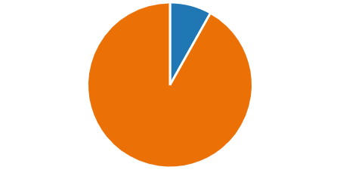
 | Yes | 57 | 8%
 | No | 641 | 92%

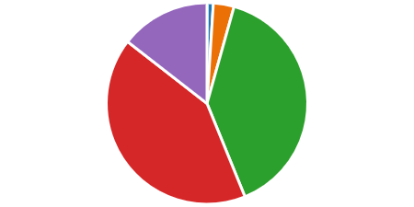
36. What is your age group?

 | Under 16 | 7 | 1%
 | 16 - 24 years | 23 | 3%
 | 25 - 44 years | 273 | 40%
 | 45 - 64 years | 288 | 42%
 | 65 & over | 100 | 14%

